# CS 255 System Design Document Template

This template lays out all the different sections that you need to complete for Project Two. Each section has guidance to prompt your thinking. You will need to continually reference the interview transcript as you work to make sure that you are addressing your client’s needs. There is no required length for the final document. Instead the goal is to complete each section based on what your client’s needs are. Remove this note when you are finished, and replace all bracketed text with the relevant information.

## UML Diagrams

### UML Use Case Diagram

*[In Module Six, you were asked to complete a use case diagram based on your system design. If you would like to make any adjustments to your diagram, please do so. Please insert your use case diagram here. Check to make sure that you included appropriate components and symbols and that your design meets the client’s needs.]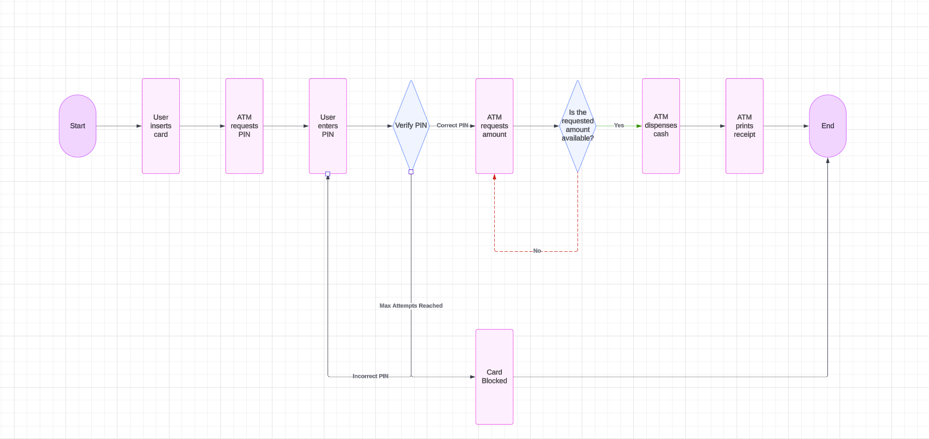*

### UML Activity Diagrams

*[You were asked to choose* ***two*** *use cases and create* ***two*** *activity diagrams, one for each use case. Please insert* ***both*** *of your activity diagrams here. Check to make sure that you included appropriate components and symbols and that your design meets the client’s needs.]  
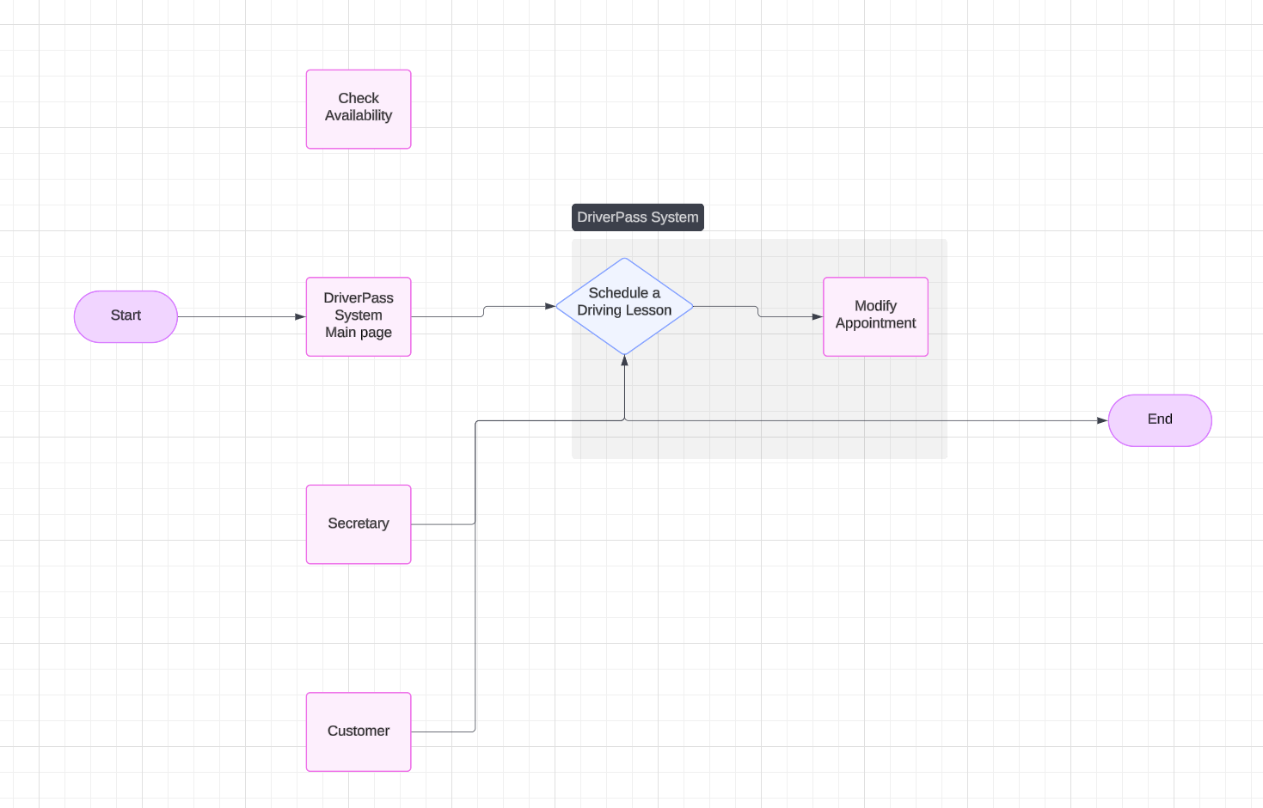*

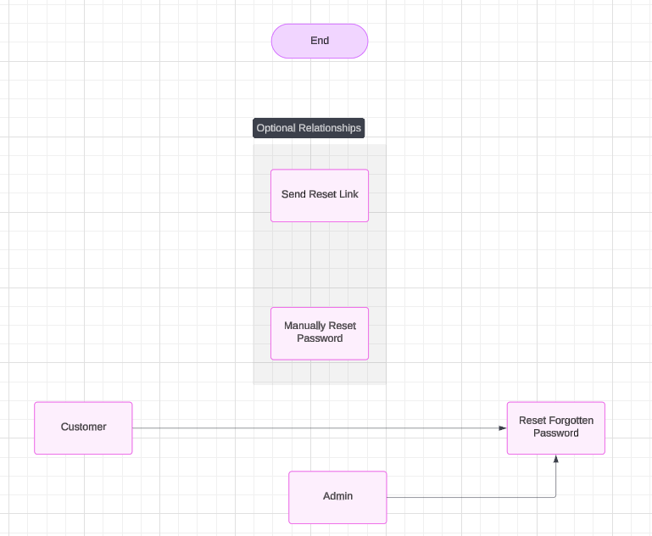

### UML Sequence Diagram

*[You were asked to create a sequence diagram based on* ***one*** *of the use cases you chose. Please insert your sequence diagram here. Check to make sure that you included appropriate components and symbols and that your design meets the client’s needs.]  
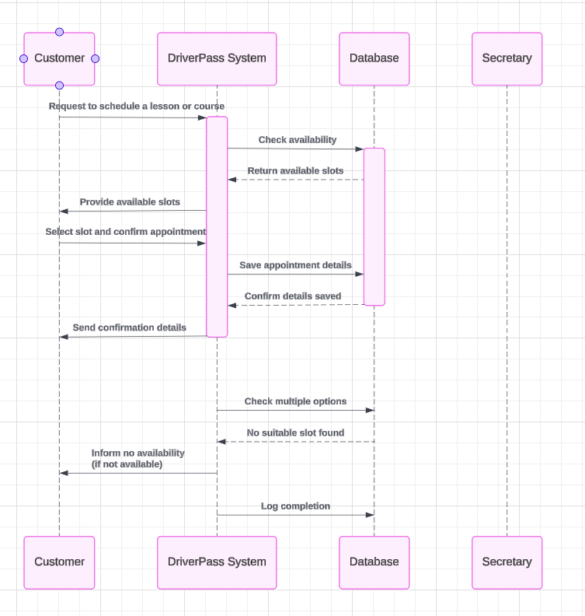*

### UML Class Diagram

*[You were asked to create a class diagram based on the different classes and attributes needed for your system design. You are* ***not*** *required to include methods, but you may if you wish. Please insert your class diagram here. Check to make sure that you included appropriate components and symbols and that your design meets the client’s requirements.]  
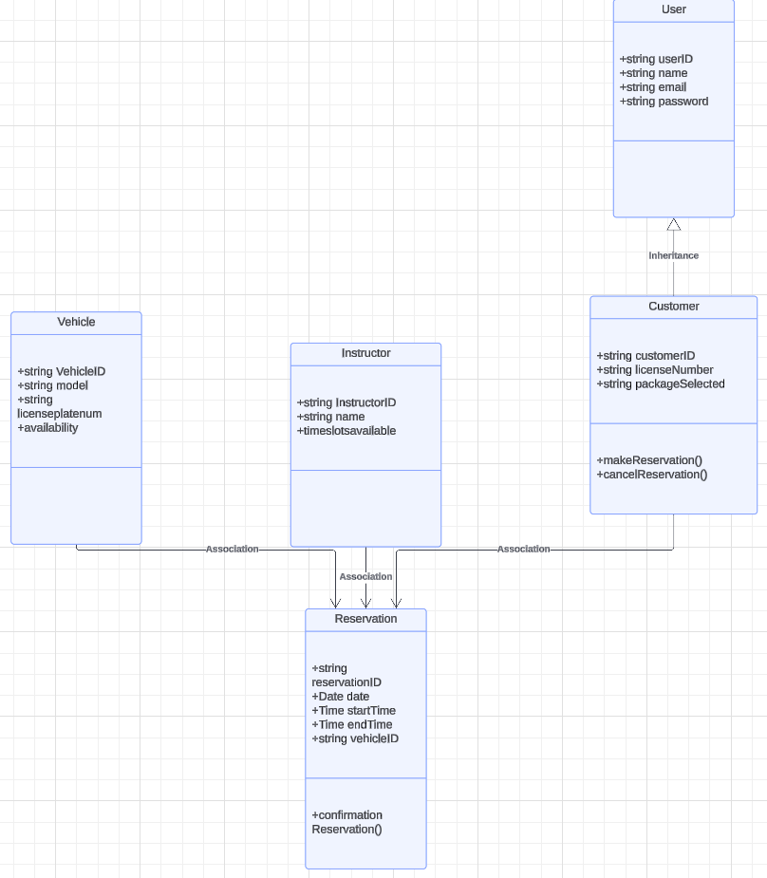*

## Technical Requirements

*[Based on the diagrams you have created, describe the technical requirements of your system. These requirements should address the required hardware, software, tools, and infrastructure necessary for your system design.]*The system for DriverPass should be able to complete the following tasks, deliver online courses and practice exams for driving license preparation. Enable users to schedule, modify, or change their driving lessons appointments and schedule to better adapt to their needs. Remind users to stay up to date on local state laws, DMV or DPS rules and policies, while training or learning. Ensure data is secure while using the online learning platform. Create intuitive and visually aesthetic learning interfaces that are easy to use for students, parents, or instructors, etc. this and many other online learning platforms should be web based, similar to how schools, institutions, and job learning websites run. This will allow for the fastest method of running on a multitude of systems from windows, mac, linux, etc. The system should be able to handle multiple users, admins, and instructors to be able to access the site, its materials, and its data at any given moment. The system should also be able to work with different time zones for different users, as to not conflict with instructor schedules. The system needs to be able to run on web browsers so that it is more accessible and less resource heavy on the user side. DriverPass should be accessible via web browsers and mobile devices as well as compatible with popular operating systems, including Windows, macOS, linux, iOS, and Android devices.DriverPass system needs to be able to differentiate between users such as different students, instructors, platform admins etc. The system should use unique identifiers such as emails, passwords, phone numbers, potentially even usernames. User input should always be case sensitive to validate that the user is inputting their information correctly and so that the system can confirm that the appropriate user is accessing the system. Live time security updates and scans is vital to keep any system up and running so that platform admins are aware of any security compromises, some examples of this would be a report of too many sign in attempts may indicate that someone is trying to break into an account.